Developing an Innovative AI Strategy Framework for Canada: A Data‑Driven Analysis
MIE1624 Final Project

By: Group 7 (Edison Guo, Zhiyuan She, Ruogu Xu,
Wenyue Yang, Yi Zhang, Stella Zhao)
Date: March 29, 2026
Table of Contents
*The main body of the report starts on Page 3
1 Introduction 3
2 Data Collection and AI Competitiveness Measurement Summary 3
2.1 Implementation 3
2.1.1 Talent 3
2.1.2 Infrastructure 3
2.1.3 Operating Environment 4
2.2 Innovation 4
2.2.1 Research & Development 4
2.3 Investment 4
2.3.1 Government Strategy 4
2.3.2 Commercial 5
3 Develop Proposal for Canada’s AI Strategy 5
3.1 Diagnosis 5
3.2 Canada’s Existing AI Frameworks 5
3.3 Canada's AI Strategy 2026–2030: Vision and Four Pillars 6
3.4 Key Recommendations 7
4 Practical Steps For Implementing AI Strategy 8
4.1 National AI Talent Bridge Program 8
4.1.1 Current Status Quo And Implementation Gap 8
4.1.2 Proposed Practical Steps 8
4.1.3 Responsible Ministries And Delivery Partners 8
4.1.4 Estimated Cost And Funding Logic 8
4.1.5 Implementation Timeline (1–3 Years) 8
4.1.6 Success Metric 8
4.2 Canadian AI Compute Access Fund and Sovereign Compute Expansion 9
4.2.1 Current Status Quo and Implementation Gap 9
4.2.2 Proposed Practical Steps 9
4.2.3 Responsible Ministries And Delivery Partners 9
4.2.4 Estimated Cost And Funding Logic 9
4.2.5 Implementation Timeline (1–3 Years) 9
4.2.6 Success Metric 9
4.3 AI Governance Sprint and Canadian AI Safety and Accountability Office 9
4.3.1 Current Status Quo and Implementation Gap 9
4.3.2 Proposed Practical Steps 10
4.3.3 Responsible Ministries And Delivery Partners 10
4.3.4 Estimated Cost And Funding Logic 10
4.3.5 Implementation Timeline (1–3 Years) 10
4.3.6 Success Metric 10
4.4 AI Venture Accelerator and Commercialization Instruments Recalibration 10
4.4.1 Current Status Quo and Implementation Gap 10
4.4.2 Proposed Practical Steps 10
4.4.3 Responsible Ministries And Delivery Partners 10
4.4.4 Estimated Cost And Funding Logic 11
4.4.5 Implementation Timeline (1–3 Years) 11
4.4.6 Success Metric 11
5 Key Findings Narrative 11
5.1 Competitiveness Score Projection 11
5.2 PR Strategy: "Canada — the Country of AI Innovations" 11
5.3 Funding Narrative 12
6 Conclusion 12
References 13
Appendix 17
Appendix A: Data Visualizations During the Data Collection Process 17
A.1 Talent 17
A.2 Infrastructure 17
A.3 Operating Environment 18
A.4 Research & Development 18
A.5 Government Strategy 19
A.6 Commercial 19
Appendix B: Machine Learning Methods for Ranking Feature Importance 19
B.1 Feature Importance Methods 19
B.2 Ensemble Rank Aggregation 20
B.3 Unsupervised Methods 20
B.4 ML-validated Diagnosis Summary 21
Appendix C: Canada Rank Improvements vs. Benchmarked Nations 21
C.1 AI Talent Bridge Program: Canada vs. Benchmarked Peers 22
C.2 AI Compute Access Fund and Sovereign AI Computing: Canada vs. Benchmarked Peers 22
C.3 AI Governance Sprint and Regulation Office: Canada vs. Benchmarked Peers 22
C.4 AI Venture Accelerator: Canada vs. Benchmarked Peers 23
C.5 Cumulative Re-rank Projection: Canada vs. Benchmarked Peers 23
Appendix D: Supplementary Figures and Infographics 24
D.1 Diagnostic and priority visuals 24
D.2 Policy impact and projection 25
D.3 Storytelling and PR framework 27
D.4 Social and campaign assets 27
Appendix E: Part 5 LLM Chatbot 28

1 Introduction
In today's rapidly developing technological world, the strategic development of artificial intelligence has become important for countries to maintain their technological competitiveness through continuous innovation. According to the Tortoise Media Global AI Index ranking, Canada is one of the global leaders in AI, ranking 8th globally, with only the United States, China, Singapore, the United Kingdom, France, South Korea, and Germany outperforming Canada overall (as shown in Figure 1) [1].  As consultants appointed by the University of Toronto, to ensure Canada continues its leadership in the AI field, our primary objective is to assess Canada's position in AI innovation compared to other AI global-leading countries, improve Canada’s current AI strategies, and propose implementable steps for innovation. Therefore, to achieve this goal, we first established a benchmark for comparison. | 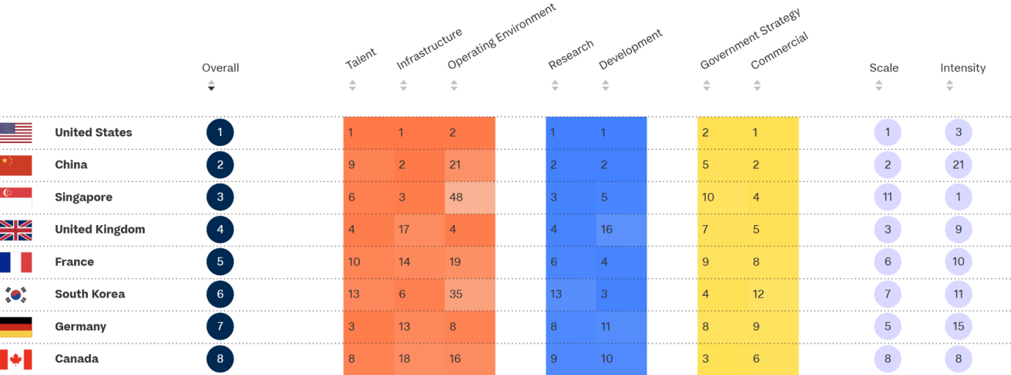  Figure 1. Tortoise Media Global AI Index Ranking of Countries in AI Competitiveness [1]
We adapted the authoritative AI capacity ranking table published on Tortoise Media’s Global AI Index as our ranking of countries’ AI competitiveness. Since only 7 countries outperformed Canada overall, in our subsequent analysis, we will focus on these 7 countries, exploring the AI ​​strategies they have implemented that have enabled them to outperform Canada overall. We will also adapt the 6 key AI indicators (talent, infrastructure, operating environment, research & development, government strategy, and commercial) summarized by Tortoise Media as our AI indicators [1], forming the basis for our assessment of countries' AI competitiveness. Under each AI indicator, we will introduce sub-indicators. This approach allows us to spot where Canada falls behind the top 7 countries specifically, thereby being able to establish AI ​innovation strategies and practical implementation steps. We will use generative AI to assist our summarization of other countries' AI strategies in our strategy development phase.

2 Data Collection and AI Competitiveness Measurement Summary

2.1 Implementation

2.1.1 Talent
4 sub-indicators are used in the talent indicator (see Appendix A.1). In per-capita AI publications from 2020 to 2024 [2], Singapore leads at 2,783 per million, followed by South Korea (802) and the United Kingdom (800). Canada ranks fourth at 661, outperforming the United States (584) and Germany (553). In generative AI contributors on GitHub [3], the United States dominates with 80,000, far ahead of China (42,000). Canada has 7,200, placing it in the lower half of the group. In AI talent concentration on LinkedIn [4], Singapore leads at 1.64× the global average, while Canada records only 0.87×. In R&D researchers per million [5], South Korea leads with 8,615, and Canada ranks fourth at 5,076 [6]. These results suggest a research-to-industry conversion gap: Canada's education pipeline is strong, but commercial talent absorption is weak. It is important that Canada strengthen talent retention and industry-academic collaboration to close this gap.

2.1.2 Infrastructure
4 sub-indicators are used in the infrastructure indicator (see Appendix A.2). In the number of supercomputers on the Top500 list [7], the United States leads with 171 systems, far ahead of China and Germany (both 40). Canada has 19 systems, placing it in the lower half. In average download speed [8], Singapore leads at 308.8 Mbps, while Canada records 192.9 Mbps, ranking in the middle tier. In high-end GPU citations in AI research papers (2024–2025) [2], China (169) and the United States (158) far outpace all others. Canada recorded only 20 citations, behind Germany (37) and South Korea (33). In integrated circuit exports [9], China ($171.2B) and South Korea ($139.4B) lead significantly, while Canada's exports are the lowest at $0.7B. These results suggest that Canada's infrastructure gap is most pronounced in computing capacity and semiconductor manufacturing. It is important that Canada prioritize sovereign compute investment and GPU access.

2.1.3 Operating Environment
4 sub-indicators are used in the operating environment indicator (see Appendix A.3). In AI-related bills passed into law (2016–2024) [10], the United States leads with 27 bills, followed by South Korea (13). Canada passed only 1 bill, ranking seventh of eight countries. In legislative mentions of AI in 2024 [10], the United Kingdom leads with 710 mentions, and Canada ranks third with 417 — showing strong parliamentary awareness but weak legislative output. In public trust in AI data protection [10], China leads at 66%, while Canada records only 28%, the lowest among all benchmark countries. In workforce AI readiness [10], the United States leads at 2.63× the global average, and Canada ranks fourth at 1.30×. These results reveal a disconnect between legislative rhetoric and regulatory action, combined with critically weak public trust. It is important that Canada enact concrete AI legislation and build visible accountability mechanisms to close this gap.

2.2 Innovation

2.2.1 Research & Development
3 sub-indicators are used in the research & development indicator (see Appendix A.4). Among the global top 100 highly cited publications (2021-23) [11], the United States contributed to more than half (>50) of the publications every year, followed by China which contributed to about one third (>33) every year. For the 6 remaining countries including Canada, the contributions were all very low with no significant difference. As for the number of granted AI patents per 100,000 inhabitants [11], in 2023, it was recorded that South Korea had a significantly higher number (~17 patents) compared to all other 7 countries, followed by China (~6 patents) and the United States (~5 patents). The remaining countries had nearly negligible numbers (i.e., 0-1), with Canada ranking last (~0.17 patents). Lastly, from the data of google searches in AI which reflects public interest in AI [12], China, South Korea, and Singapore outperformed significantly throughout 2015 to 2025 compared to other countries. Canada ranked mostly in 4th place, performing relatively better than the remaining countries. To conclude, Canada has a lot of room for improvement in all 3 sub-indicator categories, especially in the contribution in the number of highly cited publications in the top 100 and the number of granted AI patents per 100,000 inhabitants. It is important that Canada starts to pay more attention in AI research & development.

2.3 Investment

2.3.1 Government Strategy
2 sub-indicators are used in the research & development indicator (see Appendix A.5). As seen from the total allocated budget for AI in each country [13], the United States and China were spending much more than the rest of the countries in 2025. Specifically for Canada, the United States (~490 billion USD) was spending about 30 times more than Canada (~15 billion USD). While in the government's strength to enable technical infrastructure for AI implementation in 2025 (scored on a scale from 0 to 100) [14], Canada’s performance was average. These data suggest that Canada is investing in AI, but the level of investment is falling behind. Hence, Canada can consider raising its financial commitment in AI, while maintaining its strength in enabling technical infrastructure.

2.3.2 Commercial
3 sub-indicators are used in the research & development indicator (see Appendix A.6). Based on the total number of newly funded AI companies per capita [11][15] and AI startups per capita [15][16] over the past decade, we see Canada performing average, with only Singapore having noticeably more compared to all other countries. In terms of the venture capital investments in AI [12], over the years, the United States is accelerating sharply in VC investments, outdistancing all other countries. In 2025, the United States’s VC investment was 194,115 millions USD, which is over 60 times more than Canada (3,078 millions USD). China, on the other hand, although showing a decline in VC investments in recent years, its total is still outstanding compared to the remaining countries. Therefore, Canada can have better improvement in the commercial domain by expanding targeted venture capital investment for AI.

3 Develop Proposal for Canada’s AI Strategy

3.1 Diagnosis
Canada's 8th-place ranking on the Tortoise Media Global AI Index reflects a structural imbalance: strong inputs — academic research, R&D density, and parliamentary discourse — paired with weak outputs — commercial activity, legislation, venture capital, and compute. A machine-learning feature importance analysis (ensemble of Random Forest, Gradient Boosting, Lasso, and Pearson Correlation across 19 features, detailed in Appendix B) confirms this quantitatively: AI Publications per Million and AI Talent Concentration rank last in predictive importance (0.18 each), while the top features are all output-side metrics where Canada's gaps are greatest. Four structural challenges follow:
Talent conversion gap. Despite ranking 4th in per-capita AI publications and R&D researchers, Canada ranks 6th in AI professional concentration and generative AI developer activity. GenAI GitHub Contributors is the #1 most important feature (importance = 0.92), with Canada's normalized gap at +0.31 versus the top-5 average — confirming talent is being trained but not commercially retained.
Fragile compute infrastructure. With only 19 Top500 supercomputers, 20 high-end GPU citations in 2024–25 research papers, and $0.7B in integrated circuit exports — the lowest in the benchmark group — Canada lacks sovereign compute capacity. Government AI Budget ranks 5th in importance (0.67); Canada's $15B commitment is 3% of the U.S.'s $490B.
Regulatory gap. Despite AI appearing 417 times in parliamentary proceedings in 2024 (3rd globally), Canada enacted only one AI-related bill between 2016–2024 (7th globally). Public Trust in AI ranks 3rd in importance (0.71) and represents Canada's largest single gap (+0.479), with public trust at just 28% — the lowest among all benchmark countries. Notably, AI Legislative Mentions ranks only 14th in importance, confirming that discourse without enacted law does not predict competitiveness.
Underfunded commercial ecosystem. Canada attracted $3.1B in AI venture capital in 2025 — 63× less than the U.S. ($194.1B). AI Companies per Capita (importance = 0.70, ranked 4th) and Venture Capital Investment (0.62, ranked 7th) together confirm that commercial density and growth-stage capital are among the strongest structural predictors of AI rank.

3.2 Canada’s Existing AI Frameworks
Looking at the existing Canadian AI frameworks, three strategies currently anchor Canada’s national AI approach. First of all, the Pan-Canadian AI Strategy, administered by CIFAR across three national institutes (such as Mila, Vector Institute, and Amii), successfully established Canada as a hub for fundamental AI research and built the academic talent pipeline reflected in Canada's strong per-capita publication metrics [17]. However, it was designed for research capacity, not commercial translation, which causes the talent-to-industry conversion gap as shown in Section 2.1.1. Moreover, the $2 billion Sovereign AI Compute Strategy is directionally correct in addressing infrastructure sovereignty, but is insufficient in scale against a United States commitment of approximately $490 billion, and does not address near-term GPU access or semiconductor supply chain participation, further proving Canada's most acute infrastructure vulnerability as shown in Section 2.1.2 [18][19]. Lastly, the AI Strategy for the Federal Public Service 2025–2027 targets internal government efficiency rather than national competitiveness, and does not address the legislative gap or public trust deficit identified in Section 2.1.3 [20]. Thus, Canada’s existing AI framework addresses one dimension of the problem in isolation: research capacity, compute infrastructure, and internal government adoption, respectively. However, none of them provides the solution to the deficient areas in commerce, infrastructure to access, or legislative intent to enact law.

3.3 Canada's AI Strategy 2026–2030: Vision and Four Pillars
Canada's strategy targets top-five global AI standing by 2030 by converting world-class research into competitive products, maintaining sovereign compute, governing with clarity, and retaining homegrown talent. This vision is grounded in Canada's research institutions, multicultural talent pipeline, multilateral relationships, and democratic governance, and is achievable within five years if the four pillars below receive the required funding, coordination, and accountability.
Pillar 1: Talent Retention and Commercial Conversion. Canada will close the gap between strong academic output and weak commercial AI workforce through industry-academia transition programs, expanded AI immigration pathways, and financial incentives for professionals to build domestically. The target is raising AI talent concentration from 0.87× to 1.20× the global average by 2028 and doubling Canadian-based generative AI contributors on GitHub by 2030 [21]. Primary models: Singapore's targeted immigration and industry co-investment (1.64× concentration) and South Korea's STEM pipeline (8,615 R&D researchers per million) [21][22].
Pillar 2: Sovereign Compute and Infrastructure. Canada will expand sovereign compute beyond its initial $2B commitment, targeting 60+ Top500 systems by 2030 — tripling the current 19 — alongside a national GPU access program for researchers and enterprises [18][23]. Bilateral agreements with South Korea and the U.S. will target growth in integrated circuit exports from $0.7B to $5B by 2030 [9]. Primary models: the U.S. (171 Top500 systems, 158 GPU citations), South Korea ($139.4B IC exports), and the U.K.'s bilateral GPU access model [23][24][25].
Pillar 3: Regulation, Governance, and Public Trust. Canada will enact at least 8 additional AI bills by 2028 — bringing its total from 1 to 9, on par with the U.K. [24] — supported by a standing Parliamentary AI Committee, mandatory 90-day public consultations, and a new Canadian AI Safety and Accountability Office. The target is raising public trust in AI from 28% to 40% by 2028 [24]. Primary models: the U.K.'s AI Safety Institute and South Korea's 13 enacted AI bills [24].
Pillar 4: Commercialization and Venture Capital. Canada will launch a dedicated AI Venture Accelerator — a $3B+ public-private co-investment fund targeting Series A and B companies — complemented by AI-specific R&D tax credits, a national AI procurement commitment, and a diaspora engagement program. The target is growing annual AI venture capital from $3.1B to $15B by 2030 [24]. Primary model: Singapore's Enterprise Singapore co-investment model and highest per-capita AI startup density [26].

3.4 Key Recommendations
The four strategic pillars above each correspond to one key recommendation below.

Recommendation 1: Launch a National AI Talent Bridge Program. Canada's talent gap is not a supply problem, but rather a retention and conversion problem. As Section 2.1.1 demonstrates, Canada ranks 4th in per-capita AI publications and 4th in R&D researcher density, yet falls to 6th in both commercial AI workforce concentration and generative AI developer activity [21][22][24][27]. The talent exists; the domestic commercial pathways to absorb it do not. Singapore's AI talent concentration of 1.64× the global average and South Korea's R&D researcher density of 8,615 per million, both achieved through structured industry-academia linkages and domestic employment incentives documented in Section 2.1.1, demonstrate that commercial talent absorption requires deliberate policy beyond research funding alone [21][22]. Canada already has a proven model in Mitacs; the recommendation is to scale it with an explicit commercial conversion mandate, directing public investment toward the transition from academic AI research to domestic industry rather than research output alone [28].

Recommendation 2: Establish a Canadian AI Compute Access Fund and expand the Sovereign Compute Strategy. Canada's infrastructure deficit is both a research constraint and a commercial competitiveness problem. As Section 2.1.2 shows, Canada recorded only 20 high-end GPU citations in AI research papers in 2024–2025 — below Germany (37), South Korea (33), and the United Kingdom (29) [24] — and holds the lowest integrated circuit export value among all benchmark countries at $0.7 billion [24][25]. The existing Sovereign Compute Strategy is directionally correct but insufficient in scale and does not address near-term GPU access [18]. The United States' 171 Top500 systems and dominant GPU access, South Korea's $139.4 billion semiconductor export position, and the United Kingdom's bilateral GPU access agreements, all documented in Section 2.1.2, demonstrate that sovereign compute investment and semiconductor supply chain participation are complementary strategic assets, not alternatives [23][24][25]. Canada must pursue both simultaneously, with near-term subsidized access bridging the gap while longer-term domestic capacity is built.

Recommendation 3: Enact an AI Governance Sprint and Establish a Canadian AI Safety and Accountability Office. Canada's regulatory gap is a prioritization and process failure, not a resource problem. As Section 2.1.3 shows, Canada ranks 3rd globally in parliamentary AI discourse with 417 mentions in 2024, yet has enacted only one AI-related bill since 2016, ranking 7th among benchmark countries [24]. Simultaneously, it records the lowest public trust in AI data practices among all eight benchmark countries at 28% [24]. These two findings are connected: legislative ambiguity and the absence of visible accountability institutions are primary drivers of public distrust. The United Kingdom's 10 enacted AI bills and AI Safety Institute, and South Korea's 13 enacted bills, both documented in Section 2.1.3, demonstrate that high legislative output is achievable without sacrificing innovation pace when regulatory design is iterative and industry co-developed [24]. Canada must convert its parliamentary AI awareness into enacted law and institutional accountability structures, or risk both investment uncertainty and sustained public opposition to AI adoption.

Recommendation 4: Establish a dedicated AI Venture Accelerator and recalibrate commercial AI instruments. Canada's commercial AI ecosystem is structurally underfunded and institutionally misaligned. As Section 2.3.2 shows, Canada attracted only $3.1 billion in AI venture capital in 2025
— over 60 times less than the United States ($194.1 billion) — and its AI startup density is not producing companies that scale to global significance at a competitive rate [24]. The root cause is not a lack of early-stage activity but a lack of growth-stage capital and commercially targeted government instruments. Canada's existing tools — the Business Development Bank of Canada, Export Development Canada, and the Strategic Innovation Fund — are broadly oriented and not calibrated to the specific risk profile, commercialization timeline, and global scaling requirements of AI ventures. Singapore's highest per-capita AI startup density, achieved through direct government co-investment via Enterprise Singapore and preferential tax treatment for AI ventures documented in Section 2.3.2, demonstrates that targeted public co-investment through a dedicated vehicle is the mechanism most directly correlated with high AI venture activity among peer nations [26]. Canada should establish a dedicated AI Venture Accelerator — a public-private co-investment fund of at least $3 billion — focusing exclusively on Series A and Series B AI companies with demonstrated paths to global scale, complemented by AI-specific R&D tax credits and a national AI procurement commitment.

4 Practical Steps For Implementing AI Strategy

4.1 National AI Talent Bridge Program

4.1.1 Current Status Quo And Implementation Gap
Canada’s AI talent challenge is less a research supply problem than a commercialization gap. Statistics Canada reported that 6.1% of businesses used AI in the 12 months before Q2 2024, rising to 12.2% in Q2 2025. This suggests Canada has strong talent and research capacity [29], but lacks an effective bridge from research institutions to domestic industry, leading to talent loss to other countries.

4.1.2 Proposed Practical Steps
Canada should launch a National AI Talent Bridge Program built on three measures. First, expand industry-academic pathways through a dedicated AI stream in programs such as Mitacs and university AI programs, with placements aimed at startups, scaleups, and applied AI teams [28]. Second, provide C$60–100 million per year in short-term wage support for fellowships, co-ops, and startup hiring incentives, supporting about 5,000–8,000 AI-related jobs [29][30]. Third, strengthen existing fast-track immigration pathways through adding an AI exclusive pathway outside of S.T.E.M. to help Canadian firms recruit 3,000–5,000 highly skilled AI professionals each year [31].

4.1.3 Responsible Ministries And Delivery Partners
The National AI Talent Bridge Program should be led by ISED, with Mitacs delivering national industry-academic placements and IRCC supporting fast-track entry for international high-skill talent [32][34].

4.1.4 Estimated Cost And Funding Logic
A reasonable starting budget for the National AI Talent Bridge Program is C$80 million per year. This level of funding would be sufficient to support several thousand AI-focused placements annually.

4.1.5 Implementation Timeline (1–3 Years)
Year 1 should focus on program design and pilot placements through existing partners. Year 2 should expand the program nationally, with wage support and startup funding incentives. By Year 3, the program should be fully operational and evaluated based on retention, placement, and industry absorption outcomes.

4.1.6 Success Metric
12-month retention of AI workers in Canadian firms. This directly measures whether the program helps move AI talent from research and training into long-term domestic industry employment.

4.2 Canadian AI Compute Access Fund and Sovereign Compute Expansion

4.2.1 Current Status Quo and Implementation Gap
In Budget 2024, the Federal Government announced C$2 billion over five years for a new AI Compute Access Fund and a Canadian Sovereign AI Compute Strategy, confirming that compute capacity is now seen as essential to national competitiveness. However, the government’s own consultation summary also shows that stakeholders continue to view access to affordable, high-performance computers as a major barrier for Canadian AI developments [35]. This suggests that Canada’s current approach is directionally correct, but still needs faster and stronger implementation.

4.2.2 Proposed Practical Steps
Canada should strengthen its AI computing capacity in two ways. First, the federal government should use the AI Compute Access Fund to subsidize cloud and computing purchases for Canadian SMEs, startups, and scaleups investing in AI commercialization, particularly those facing costs of C$100,000–C$5,000,000, the program’s existing funding range. Second, Canada should expand domestic sovereign capacity by accelerating projects under the AI Compute Challenge to support new or expanded Canadian AI data centres and increase access to advanced GPUs [36].

4.2.3 Responsible Ministries And Delivery Partners
This project should be led by Innovation, Science and Economic Development Canada (ISED). The main delivery partners should include the National Research Council of Canada (NRC) for research and industrial coordination, the Digital Research Alliance of Canada for national research-computing access [32][34].

4.2.4 Estimated Cost And Funding Logic
The Access Fund already provides up to C$300 million to help Canadian firms, while the AI Compute Challenge may provide up to C$700 million for domestic AI data-centre expansion [37]. Rather than creating new funding, Canada should focus on directing these existing funds toward affordable GPU access [18].

4.2.5 Implementation Timeline (1–3 Years)
Year 1 should expand access to GPU and cloud resources through the AI Compute Access Fund to ease affordability barriers. Year 2 should extend support to domestic infrastructure, including new or upgraded data centres. By Year 3, Canada should have increased domestic GPU computing capacity.

4.2.6 Success Metric
The primary success metric should be the number of Canadian firms and research teams accessing subsidized GPU computing resources annually. This directly reflects whether the program is improving access to high-performance computing.

4.3 AI Governance Sprint and Canadian AI Safety and Accountability Office

4.3.1 Current Status Quo and Implementation Gap
At the federal level, governance tools such as the Directive on Automated Decision-Making and the new AI Strategy for the Federal Public Service 2025–2027 mainly focus on responsible AI use within government, rather than providing a broad national governance framework for the general public [36].

4.3.2 Proposed Practical Steps
To strengthen AI governance, Canada should adopt a structured and time-bound implementation approach. First, the Federal Government should launch an AI Governance Sprint, bringing together policymakers, industries, and research institutions to accelerate the development of targeted AI legislation. Second, a standing Parliamentary AI Committee should be established to ensure continuous oversight and coordination. Third, Canada should create a dedicated AI Safety and Accountability Office responsible for monitoring AI deployment, publishing annual reports, and enforcing transparency [20].

4.3.3 Responsible Ministries And Delivery Partners
This measure should be led jointly by ISED and the Treasury Board Secretariat, with the Department of Justice supporting legislative design and compliance, and Parliament providing ongoing oversight through a standing committee[33] [38].

4.3.4 Estimated Cost And Funding Logic
Not Applicable

4.3.5 Implementation Timeline (1–3 Years)
In Year 1, the Federal Government is to launch the AI Governance Sprint and establish the standing parliamentary oversight structure. In Year 2, the first package of targeted AI governance regulation will be introduced and the AI Safety and Accountability Office should begin operations. By Year 3, the governance framework should be fully active, with regular public reporting, oversight, and policy review [42].

4.3.6 Success Metric
The primary success metric should be the number of AI-related policies or legislative measures enacted within the three-year period, reflecting progress in moving from discussion to implementation. A complementary indicator could be the level of public trust in AI systems, measured through surveys.

4.4 AI Venture Accelerator and Commercialization Instruments Recalibration

4.4.1 Current Status Quo and Implementation Gap
Canada has a growing AI and VC ecosystem, but commercialization support remains weak, especially at the scale-up stage. BDC’s 2025 VC review and recent federal AI strategy discussions both highlight the need for stronger support to help domestic AI firms scale and attract investment [39][43].

4.4.2 Proposed Practical Steps
To strengthen commercialization, Canada needs to launch a dedicated AI Venture Accelerator with a federal commitment of about C$500 million to co-invest in high-potential Canadian AI firms at the Series A and Series B stages, where expansion funding is often the hardest to secure. The accelerator should be paired with existing SR&ED support, which currently provides a 35% refundable tax credit for eligible CCPCs on up to C$3 million of qualified annual expenditures, helping Canadian firms with expenditures through R&D tax relief [40]. Together, these measures would improve access to growth capital, strengthen domestic demand, and give more Canadian AI firms a realistic pathway to global scale [45].

4.4.3 Responsible Ministries And Delivery Partners
This measure should be led by ISED, with BDC as the main co-investment partner and the Department of Finance supporting alignment with tax incentives such as SR&ED [39].

4.4.4 Estimated Cost And Funding Logic
The AI Venture Accelerator should provide a C$500 million federal commitment to co-invest in Canadian AI firms at the Series A and B stages, in line with Canadian growth-capital benchmarks such as BDC’s expanded Growth Venture Fund [39]. With matching private capital, the total investment pool could reach about C$1–1.5 billion. It should also align with existing SR&ED tax incentives, which can provide up to a 35% refundable tax credit for eligible Canadian corporations and reduce the effective cost of R&D [41][46].

4.4.5 Implementation Timeline (1–3 Years)
Year 1 should focus on setting up the fund and securing private co-investment partners. Year 2 should launch the first investment round and procurement pilots. By Year 3, the accelerator should be fully operational, with multiple funding cycles completed and early results evaluated.

4.4.6 Success Metric
The primary success metric should be the amount of venture capital invested in Canadian AI firms annually, particularly at the Series A and B stages. A complementary indicator could be the number of AI firms successfully scaling beyond early-stage funding, reflecting improved commercialization outcomes[47].

5 Key Findings Narrative

5.1 Competitiveness Score Projection
To quantify the impact of the proposed policy package, we used the same PLS regression model specified and fitted in Part 3 to project Canada's competitiveness score under two scenarios: (1) a status-quo path reflecting only incremental gains from existing programs, and (2) a combined policy path implementing all four strategic pillars. For the status-quo scenario, we estimated yearly increments attributable to programs already in place: the Sovereign AI Compute Strategy contributes approximately one additional supercomputer and one additional GPU citation per year; the Pan-Canadian AI Strategy pipeline adds roughly 150 generative AI contributors per year; and natural venture capital trends add approximately $0.1 billion per year. No gains were assumed for features without corresponding existing policy, namely enacted AI legislation, public trust, and semiconductor exports. The resulting annual feature vectors were then passed through the same Part 3 model. Under the status quo, Canada's score rises from 2.03 to only 2.17 by 2030, remaining near rank 7 throughout. Under the combined policy package, the score reaches 4.25 by 2028 (surpassing France) and 5.30 by 2030 (approaching the United Kingdom at 5.0), a policy gain of +3.13 points. This projection is shown in Figure D.6.

5.2 PR Strategy: "Canada — the Country of AI Innovations"
The core positioning message is: Canada is where trusted AI is built, scaled, and governed.
This message gives Canada a differentiated international identity by combining democratic governance, multicultural talent, and strong research capacity. Compared with more market-led and state-led AI ecosystems, Canada can position itself as a country where AI innovation is not only advanced, but also trusted and accountable. Each of the three key recommendations supports a distinct PR theme.

First, "Responsible AI leadership" supports the Governance Sprint by emphasizing faster legislation, public accountability, and clearer guardrails for adoption. Second, "Canadian AI companies grow at home" supports the Venture Accelerator by countering the narrative that Canadian AI firms must relocate abroad to scale. Third, "Canada builds its AI backbone" supports Sovereign Compute expansion by signaling stronger national infrastructure for research and commercialization.
To launch this narrative, we propose three initial media angles: Canada’s AI Governance Sprint and legislative acceleration; new venture support that helps Canadian AI firms scale domestically; and sovereign compute expansion that strengthens national AI infrastructure. To support the PR strategy, we developed a series of social media post templates for X (Twitter), each paired with a campaign-style visual card. The four posts cover: (a) problem and opportunity — highlighting that Canada's AI gap lies in trust, commercialization, and compute rather than research; (b) recommendation snapshot — emphasizing that governance is the highest-ROI policy action; (c) brand story — making the case that Canadian AI firms should be able to scale at home; and (d) roadmap — outlining a phased execution plan from 2026 to 2030. The post templates and corresponding visual cards are included in Appendix D.

5.3 Funding Narrative
The funding case is not to build Canada's AI ecosystem from scratch, but to convert existing research strength into commercial scale, trusted governance, and domestic compute capacity. We therefore recommend a coordinated public investment package across four pillars: Governance Sprint, Venture Accelerator, Sovereign Compute, and AI Talent and Literacy. Together, these investments address the main bottlenecks identified in our analysis and create the conditions for Canadian AI firms, researchers, and institutions to grow at home. Further, from a funding perspective, the proposed package offers three returns: stronger economic value through retained talent and scale-up growth, stronger policy credibility through clearer AI rules and higher public trust, and stronger national capability through domestic compute infrastructure. Under the combined package, Canada's projected competitiveness score rises to 5.30 by 2030, compared with 2.17 under the status quo, supporting for timely public investment.

6 Conclusion
Canada possesses world-class AI research talent and institutions, yet its global competitiveness ranking (8th among benchmark countries) reveals a persistent research-to-industry conversion gap. Strong academic output has not translated into proportional commercial growth, domestic scaling, or public trust. Our cross-country regression analysis confirms that the highest-leverage factors for closing this gap are AI governance maturity, venture commercialization capacity, and sovereign compute infrastructure — precisely the areas where Canada underperforms relative to its research strength. To address this, we proposed four strategic pillars: (1) a Governance Sprint to accelerate AI legislation and raise public trust to 40%; (2) a Venture Accelerator to grow annual AI venture capital from $3.1B to $8B and retain scale-ups domestically; (3) Sovereign Compute expansion to reach 35 Top500 supercomputers and double GPU access; and (4) an AI Talent and Literacy initiative to strengthen the workforce pipeline. Our PLS model projects that the combined package raises Canada's competitiveness score from 2.03 to 5.30 by 2030, moving it from rank 8 to approximately rank 4 — while the status quo yields only 2.17. The window for action is narrow. The United States, China, the United Kingdom, and the European Union are all accelerating AI investment, while Canada's status-quo trajectory adds only 0.14 points over five years. Further delay would deepen talent outflows, push more domestic firms to scale abroad, and weaken Canada's ability to shape trusted AI governance internationally. We therefore urge the Government of Canada to commit to the proposed $4-5.5 billion package in the next fiscal cycle, launch the Governance Sprint in 2026 as the highest-impact early action, and establish an annual AI Competitiveness Review tied to clear KPIs. Canada has the research base, talent, and international credibility to lead; it now needs the policy infrastructure to convert these assets into sustained advantage. Canada can and should be the country where trusted AI is built, scaled, and governed.

References

[1] White, J., & Cesareo, S. (n.d.). The Global AI Index. Tortoise Media.
https://www.tortoisemedia.com/data/global-ai

[2] OpenAlex, "OpenAlex API v2," OurResearch, 2026. [Online]. Available: https://api.openalex.org/

[3] GitHub, "Octoverse 2024: AI leads Python to top language as the number of global developers surges," The GitHub Blog, Oct. 29, 2024. [Online]. Available: https://github.blog/news-insights/octoverse/octoverse-2024/

[4] E. Siu, "Here are 10 countries with the highest concentration of AI talent globally, according to new LinkedIn data," CNBC, Apr. 11, 2025. [Online]. Available: https://www.cnbc.com/2025/04/11/linkedin-these-countries-have-a-high-concentration-of-ai-talent.htm

[5] World Bank, "Researchers in R&D per million people (SP.POP.SCIE.RD.P6)," World Development Indicators, 2026. [Online]. Available: https://data.worldbank.org/indicator/SP.POP.SCIE.RD.P6

[6] Worldometer, "Countries in the world by population (2026)," 2026. [Online]. Available: https://www.worldometers.info/world-population/population-by-country/

[7] Top500 Project, "Top500 list – November 2024," Nov. 2024. [Online]. Available: https://www.top500.org/lists/top500/2024/11/

[8] Ookla, "Speedtest Global Index," 2024. [Online]. Available: https://www.speedtest.net/global-index

[9] Observatory of Economic Complexity, "Trade data: Integrated circuits (HS 8542) and semiconductor manufacturing equipment," 2024. [Online]. Available: https://oec.world/

[10] N. Maslej et al., "The AI Index 2025 Annual Report," AI Index Steering Committee, Institute for Human-Centered AI, Stanford Univ., Stanford, CA, Apr. 2025. [Online]. Available: https://hai.stanford.edu/ai-index/2025-ai-index-report

[11] Nestor Maslej, Loredana Fattorini, Raymond Perrault, Yolanda Gil, Vanessa Parli, Njenga Kariuki, Emily，Capstick, Anka Reuel, Erik Brynjolfsson, John Etchemendy, Katrina Ligett, Terah Lyons, James Manyika, Juan Carlos Niebles, Yoav Shoham, Russell Wald, Toby Walsh, Armin Hamrah, Lapo Santarlasci, Julia Betts Lotufo, Alexandra Rome, Andrew Shi, Sukrut Oak. “The AI Index 2025 Annual Report,” AI Index Steering Committee, Institute for Human-Centered AI, Stanford University, Stanford, CA, April 2025. https://doi.org/10.48550/arXiv.2504.07139

[12] OECD.AI (2026), data from OpenAlex, last updated 2026-02-02, accessed on 2026-03-06, https://oecd.ai/

[13] Spherical Insights. (2025, May). Top 10 Artificial Intelligence Spending Countries in 2025: Statistics and Facts Analysis 2024 to 2035. Spherical Insights.
https://www.sphericalinsights.com/blogs/top-10-artificial-intelligence-spending-countries-in-20
25-statistics-and-facts-analysis-2024-to-2035

[14] Oxford Insights. (2026, January). Government AI Readiness Index 2025. Oxford Insights.
https://oxfordinsights.com/ai-readiness/government-ai-readiness-index-2025/?

[15] Countries in the world by population (2026). (n.d.). Worldometer.
https://www.worldometers.info/world-population/population-by-country/

[16] Dolphyne, J. (2024, May 9). Mapped: The Number of AI Startups By Country. Think Energy Media.
https://www.thinkenergymedia.com/mapped-the-number-of-ai-startups-by-country/

[17] CIFAR, "Pan-Canadian Artificial Intelligence Strategy: Impact Assessment Report," Canadian Institute for Advanced Research, Toronto, ON, Canada, 2023. [Online]. Available: https://cifar.ca/ai/pan-canadian-artificial-intelligence-strategy

[18] Government of Canada, "Canadian Sovereign AI Compute Strategy," Innovation, Science and Economic Development Canada, Ottawa, ON, Canada, 2024. [Online]. Available: https://ised-isde.canada.ca

[19] Oxford Insights, "Government AI Readiness Index 2025," Oxford Insights Ltd., Oxford, UK, 2025. [Online]. Available: https://oxfordinsights.com/ai-readiness

[20] Government of Canada, "Artificial Intelligence Strategy for the Federal Public Service 2025–2027," Treasury Board of Canada Secretariat, Ottawa, ON, Canada, 2025. [Online]. Available: https://canada.ca

[21] LinkedIn / OECD.AI, "AI Talent Concentration Index," Organisation for Economic Co-operation and Development, Paris, France, 2024. [Online]. Available: https://oecd.ai

[22] World Bank / UNESCO UIS, "Researchers in R&D per Million People," World Bank Open Data, Washington, DC, USA, 2022. [Online]. Available: https://data.worldbank.org

[23] TOP500 Project, "TOP500 Supercomputer List," TOP500.org, November 2024. [Online]. Available: https://www.top500.org

[24] Stanford University Human-Centered AI, "Artificial Intelligence Index Report 2025," Stanford HAI, Stanford, CA, USA, 2025. [Online]. Available: https://hai.stanford.edu/ai-index/2025-ai-index-report

[25] Observatory of Economic Complexity (OEC), "Integrated Circuits — Trade Data 2024," OEC World, Boston, MA, USA, 2024. [Online]. Available: https://oec.world

[26] Tortoise Media, "Global AI Index 2025," Tortoise Media Ltd., London, UK, 2025. [Online]. Available: https://www.tortoisemedia.com/data/global-ai

[27] GitHub, Inc., "Octoverse 2024: The State of Open Source," GitHub, Inc., San Francisco, CA, USA, 2024. [Online]. Available: https://octoverse.github.com

[28] Mitacs, "Mitacs Annual Report 2024," Mitacs Inc., Vancouver, BC, Canada, 2024. [Online]. Available: https://www.mitacs.ca/wp-content/uploads/2025/09/2024-25-ISED-Annual-Report.pdf

[29] Statistics Canada, “Analysis on artificial intelligence use by businesses in producing goods or delivering services over the last 12 months, second quarter of 2024,” Jun. 20, 2024.

[30] Statistics Canada, “Analysis on artificial intelligence use by businesses in producing goods or delivering services over the last 12 months, second quarter of 2025,” Jun. 16, 2025.

[31] Immigration, Refugees and Citizenship Canada, Global Skills Strategy for Workers: Get Faster Processing. Government of Canada, 2026.

[32] Innovation, Science and Economic Development Canada, What We Heard Report: Consultations on AI Compute. Government of Canada, Mar. 26, 2025.

[33] Innovation, Science and Economic Development Canada, Canadian Sovereign AI Compute Strategy. Government of Canada, Oct. 31, 2025.

[34] Innovation, Science and Economic Development Canada, Engagements on Canada’s Next AI Strategy: Summary of Inputs. Government of Canada, Feb. 5, 2026.

[35] Digital Research Alliance of Canada, About the Alliance. 2026.

[36] National Research Council Canada, Artificial Intelligence. Government of Canada, 2026.

[37] Treasury Board of Canada Secretariat, Guide on the Scope of the Directive on Automated
Decision-Making. Government of Canada, Jun. 24, 2025.

[38] Treasury Board of Canada Secretariat, AI Strategy for the Federal Public Service 2025–2027: Overview. Government of Canada, Feb. 25, 2026.

[39] Business Development Bank of Canada, Canada’s Venture Capital Landscape 2025. 2025.

[40] Canada Revenue Agency, Get an Investment Tax Credit (ITC) – Scientific Research and Experimental Development (SR&ED). Aug. 12, 2025.

[41] Department of Finance Canada, Reforming and Enhancing the Scientific Research and Experimental Development (SR&ED) Tax Incentive Program. Dec. 13, 2024.

[42] Public Services and Procurement Canada, Departmental Plan 2026–2027. 2026.

[43] Mitacs, 2023–2024 Annual Report. Vancouver, BC, Canada: Mitacs, 2024. Available: Mitacs
annual report PDF.

[44] Business Development Bank of Canada, Growth Venture Fund. BDC Capital, 2025.

[45] Innovation, Science and Economic Development Canada, Artificial Intelligence (AI), Innovative Solutions Canada challenge page, Jul. 30, 2025.

[46] Innovation, Science and Economic Development Canada, Pathway to Commercialization. Innovative Solutions Canada, Mar. 17, 2026.

[47] Public Services and Procurement Canada and Treasury Board of Canada Secretariat, List of Interested Artificial Intelligence (AI) Suppliers, Government of Canada, Nov. 24, 2025.

Appendix

Appendix A: Data Visualizations During the Data Collection Process

A.1 Talent
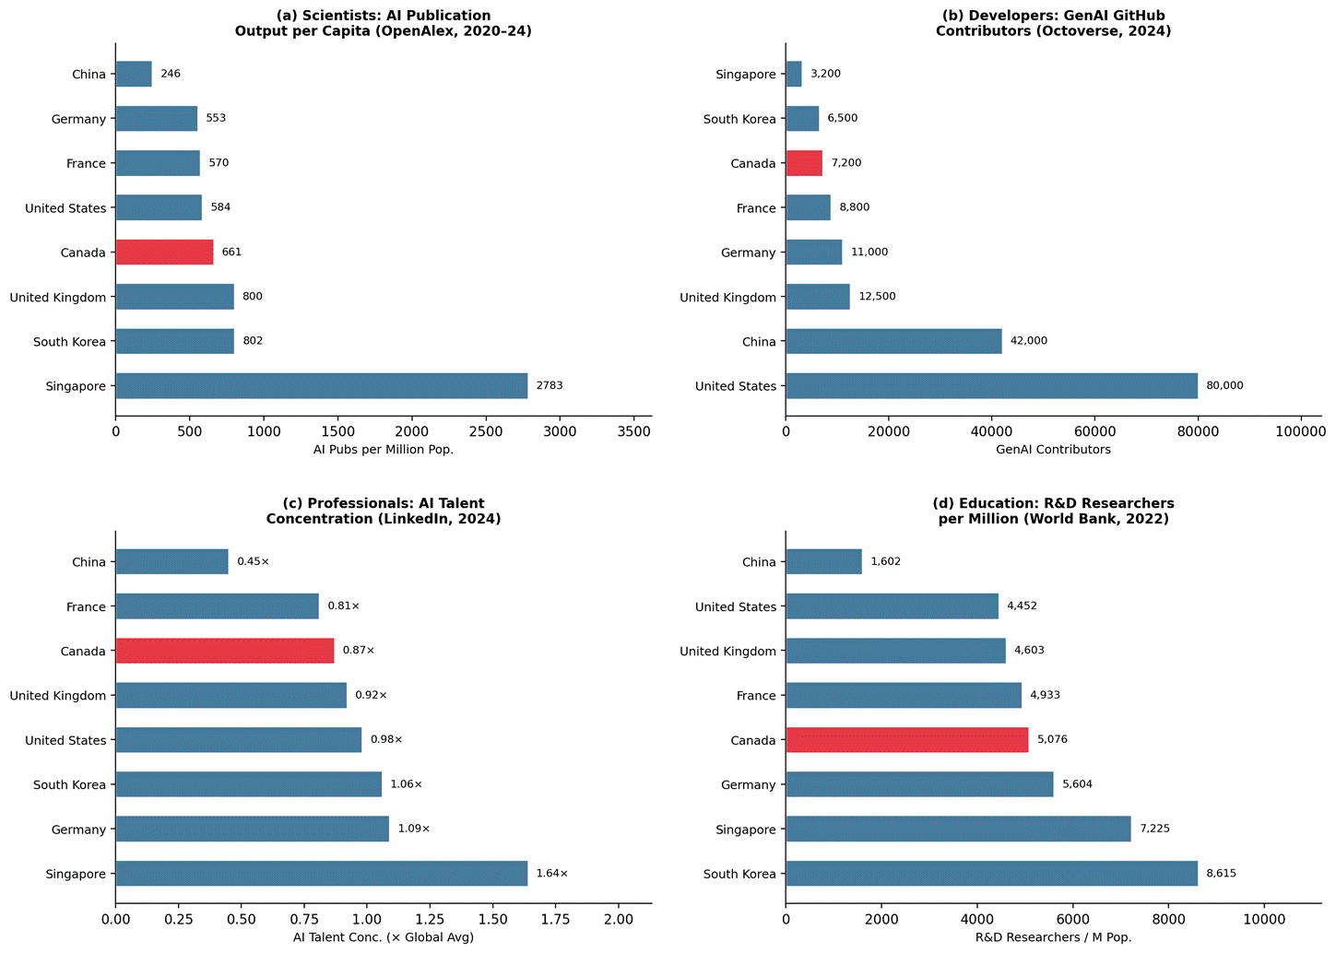
Talent sub-indicator benchmark across four pipelines: (a) per-capita AI publication output, (b) generative AI developer community, (c) AI professional concentration, and (d) R&D researcher density. Sources: OpenAlex API (2020–2024); GitHub Octoverse (2024); LinkedIn/OECD.AI (2024); World Bank/UNESCO UIS (2022).

A.2 Infrastructure
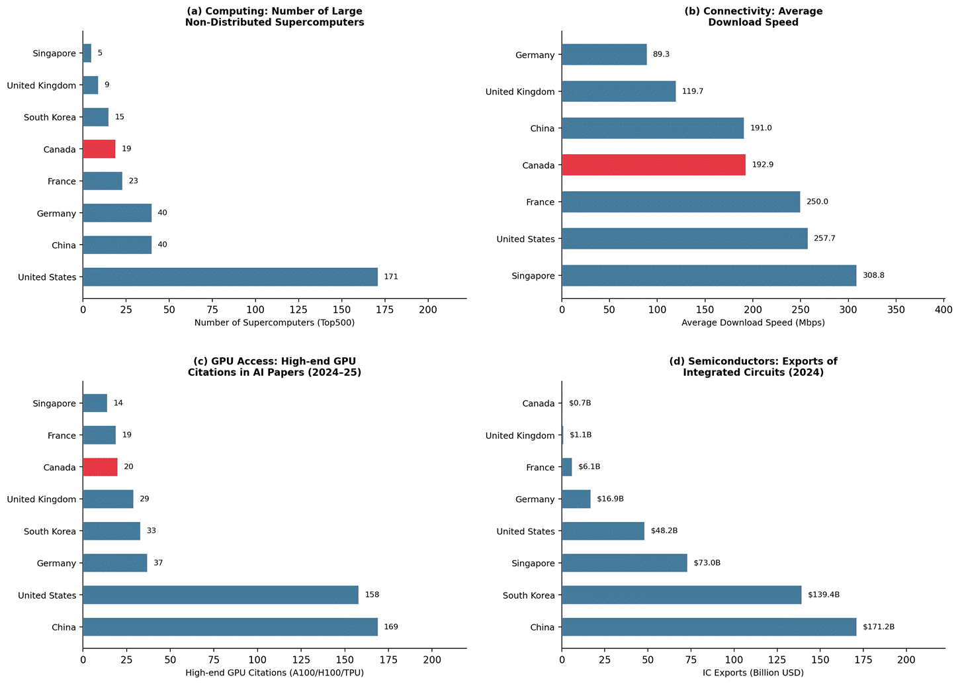
Infrastructure sub-indicator benchmark across four categories: (a) computing capacity, (b) connectivity, (c) GPU access, and (d) semiconductor trade. Sources: Top500; Speedtest; OpenAlex; OEC (2024).

A.3 Operating Environment
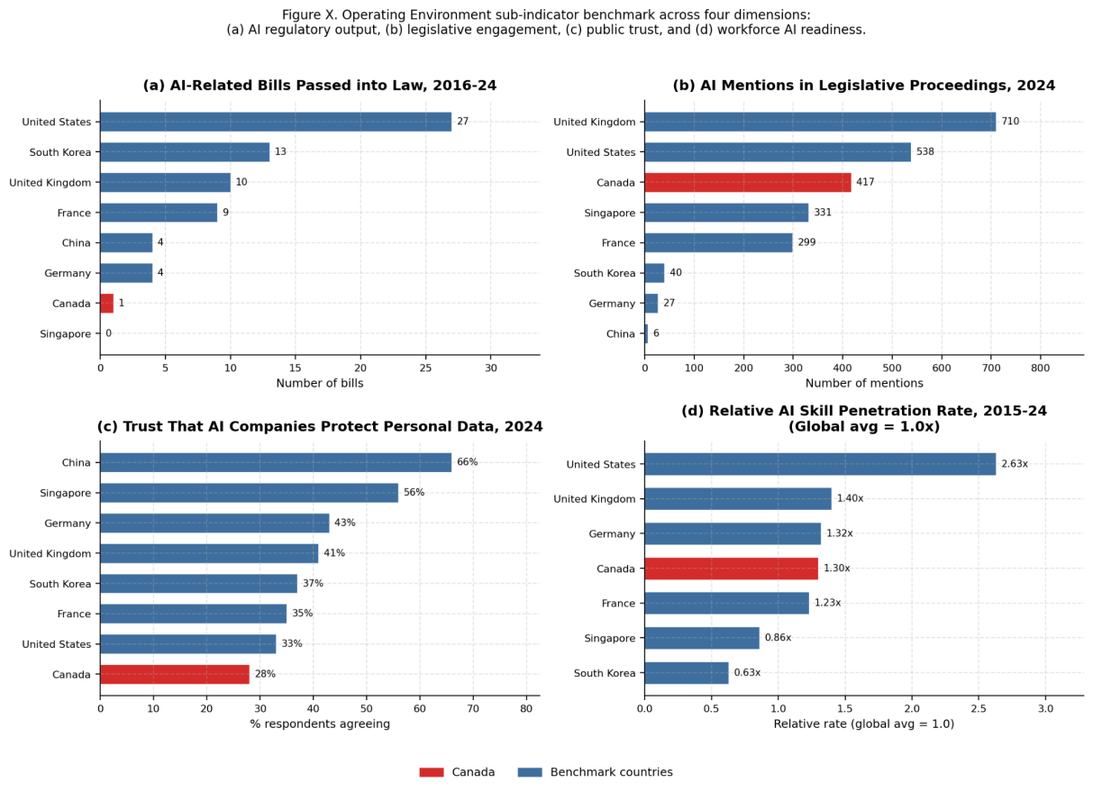
Operating environment sub-indicator benchmark across four dimensions: (a) AI regulatory output, (b) legislative engagement, (c) public trust, and (d) workforce AI readiness. Sources: Stanford AI Index 2025 — Fig 6.2.1 (Ch. 6), Fig 6.2.16 (Ch. 6), Fig 8.1.3 (Ch. 8), Fig 4.2.15 (Ch. 4).

A.4 Research & Development
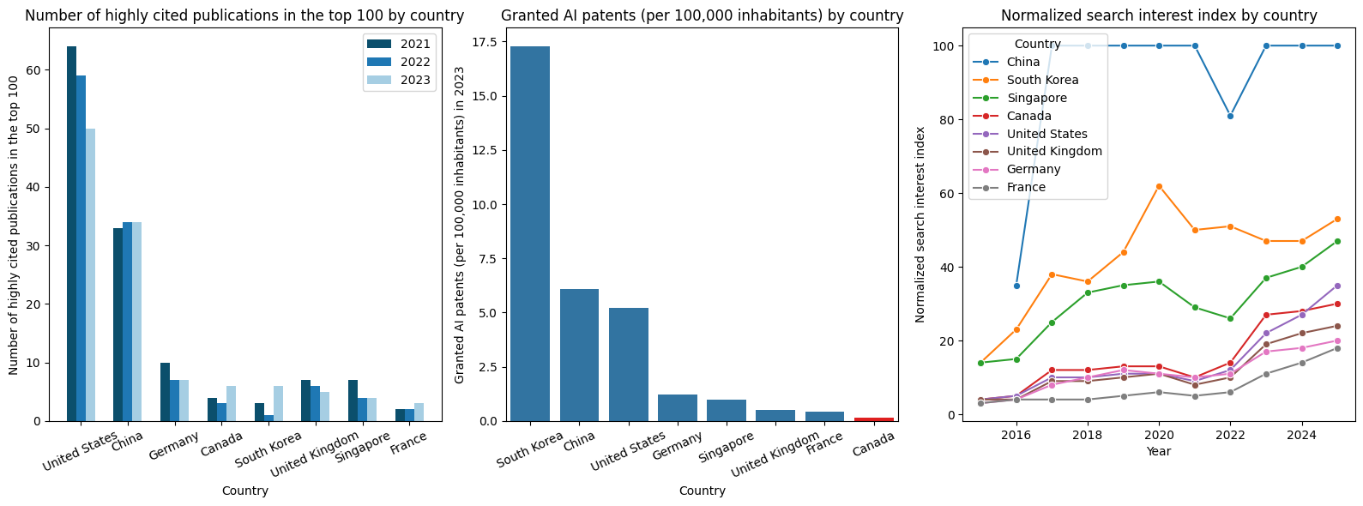
Research & development sub-indicator benchmark across three categories: (a) highly cited publications in the top 100, (b) granted AI patents, and (c) AI search index. Sources: Stanford AI Index 2025, OECD.AI.

A.5 Government Strategy
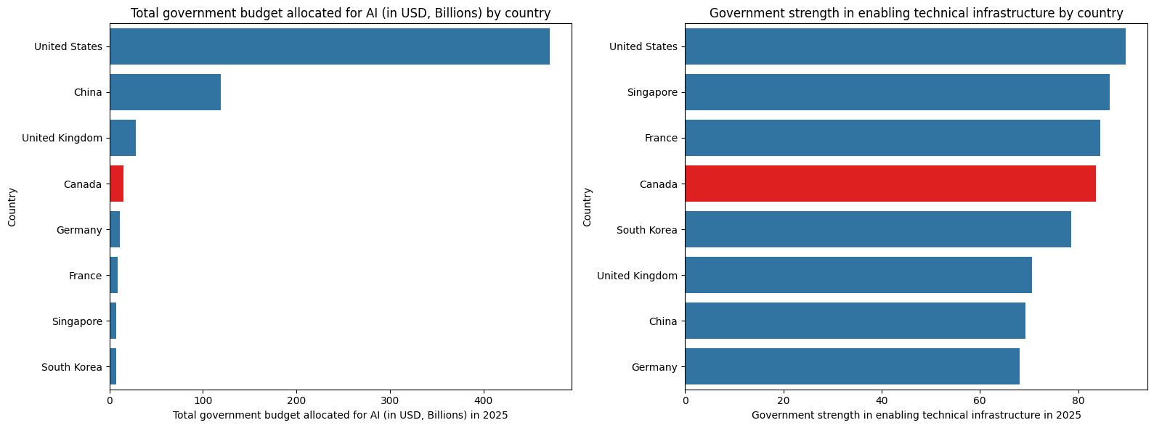
Government strategy sub-indicator benchmark across two categories: (a) government budget for AI, and (b) government strength in enabling technical infrastructure. Sources: Spherical Insights, Oxford Insights.

A.6 Commercial
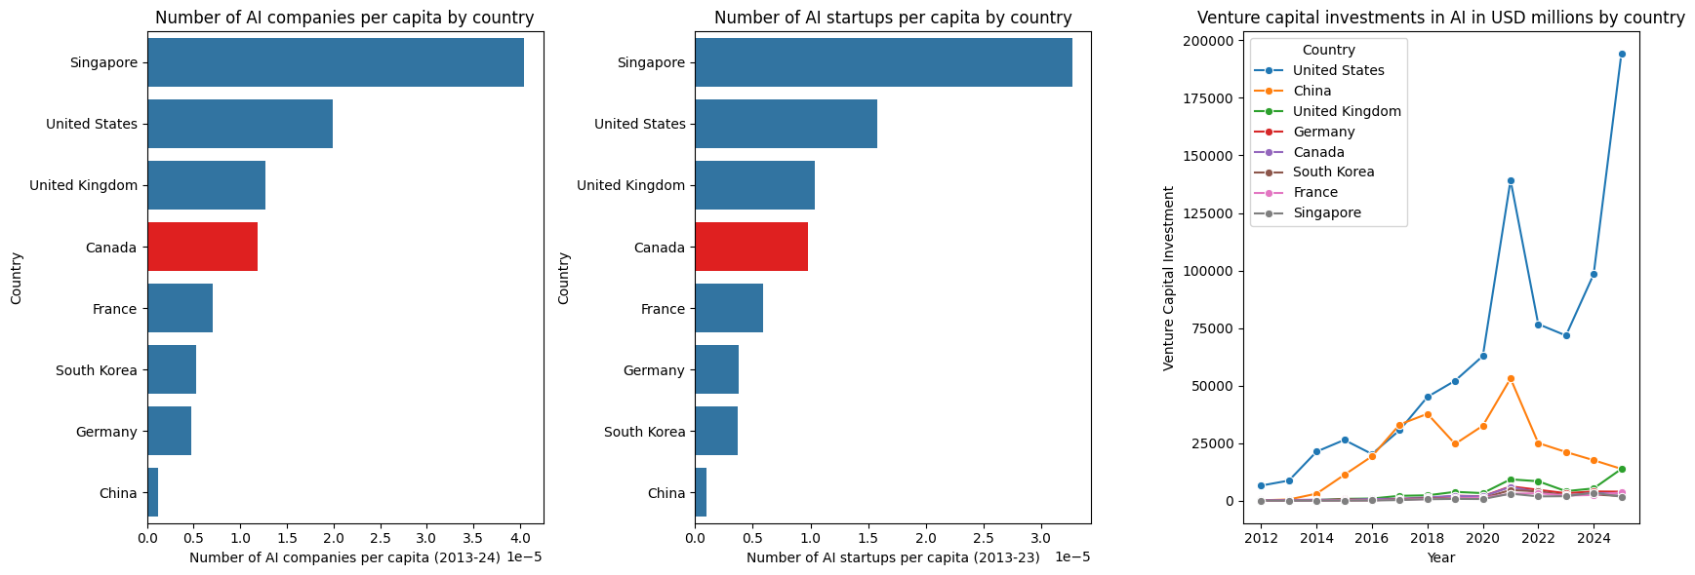
Commercial sub-indicator benchmark across three categories: (a) AI companies, (b) AI startups, and (c) venture capital investments in AI. Sources: Stanford AI Index 2025, OECD.AI, Worldometer, Think Energy Media

Appendix B: Machine Learning Methods for Ranking Feature Importance
This appendix provides a brief explanation of the four supervised learning methods used in the feature importance analysis, and describes how their results are combined into a single ensemble ranking.

B.1 Feature Importance Methods
Random Forest. A Random Forest builds a large number of decision trees (500 in this analysis), each trained on a random bootstrap sample of the data with a random subset of features considered at each split. Feature importance is measured by Mean Decrease in Impurity (MDI): how much each feature reduces prediction error across all trees on average. Features that consistently produce cleaner splits receive higher importance scores. The ensemble of many trees reduces overfitting and stabilises the ranking.

Gradient Boosting. Gradient Boosting also uses decision trees, but builds them sequentially: each new tree is trained to correct the residual errors of the previous ones. Feature importance is computed as the total weighted reduction in prediction error attributable to each feature across all trees. Because each tree focuses on the hardest-to-predict cases, Gradient Boosting tends to highlight features that differentiate the extreme ends of the ranking (e.g., what separates the United States from Canada).

Lasso (L1) Regression. Lasso fits a linear regression model with an L1 penalty that shrinks the coefficients of less informative features exactly to zero, effectively removing them from the model. The absolute value of the remaining non-zero coefficients is used as the importance score. Lasso selected 6 of the 19 features as non-zero, providing a sparse, interpretable signal of the most linearly relevant predictors. In this analysis it assigned the highest coefficient to GenAI GitHub Contributors (1.12) and the second highest to Public Trust in AI (0.86).

Pearson Correlation. For each feature, the absolute Pearson correlation coefficient |r| with the competitiveness score is computed. This is a model-free, bivariate measure that does not assume any interaction between features. It serves as a simple interpretable baseline. GenAI GitHub Contributors had the strongest correlation (|r| = 0.74), followed by GPU Citations (0.71) and Highly-Cited Publications (0.70).

Method | Importance Signal | Key Property
Random Forest | Mean Decrease in Impurity (MDI) | Captures non-linear interactions; stable over many trees
Gradient Boosting | Weighted impurity reduction per split | Sequential correction reduces bias; sensitive to influential samples
Lasso (L1) | Absolute regression coefficient | Drives unimportant features to zero; best linear signal
Pearson Correlation | Absolute correlation |r| with score | Model-free baseline; interpretable but assumes linearity

B.2 Ensemble Rank Aggregation
Because each method has different assumptions and blind spots, results are combined using Borda count rank aggregation. Each feature is ranked 1–19 by every method (1 = most important). The four rank positions are averaged into a single ensemble rank score — lower is better. This approach is robust: a feature must consistently rank highly across all four methods to reach the top of the ensemble, reducing the risk that any single model's noise drives the final ranking. GenAI GitHub Contributors, for example, ranked 7th (RF), 1st (GB), 1st (Lasso), and 1st (Correlation), yielding an average rank of 2.50 — the best in the ensemble.

B.3 Unsupervised Methods
PCA (Principal Component Analysis). PCA transforms the 19 correlated features into a smaller set of orthogonal components that capture the most variance. The first three components explained 81.1% of total variance (PC1: 40.6%, PC2: 22.7%, PC3: 17.8%). The biplot visualises countries in this reduced space and overlays feature loading vectors to show which features drive each axis.

K-Means Clustering. K-Means partitions countries into k groups by minimising within-cluster variance across all 19 features. With k = 3, the algorithm identified an AI Leader cluster (United States), an AI Challenger cluster (China), and an AI Emerging cluster (the remaining six countries including Canada). Canada's position within the Emerging cluster — closest to the United Kingdom and Singapore — is consistent with the policy benchmarks recommended in Section 3.

Leave-One-Out Cross-Validation (LOO-CV). With only 8 observations, LOO-CV is the most appropriate validation strategy. Each country is held out once as the test case while the model trains on the remaining 7. The Random Forest achieved an RMSE of 2.88 on the 8-point score scale. The small sample size limits predictive precision, but the consistent agreement across all four importance methods provides confidence that the feature rankings reflect genuine signal.

B.4 ML-validated Diagnosis Summary
Challenge | Top ML Signal | Key Finding
Talent Conversion Gap | #1 GenAI Contributors (imp. 0.92, gap +0.31) | AI Pubs/Million ranks last (#19, imp. 0.18) — inputs do not drive rank
Fragile Infrastructure | #5 Govt AI Budget (imp. 0.67, gap +0.25) | GPU Citations #6 (gap +0.37); IC Exports #12 (gap +0.35)
Regulatory Environment Gap | #3 Public Trust (imp. 0.71) — largest gap +0.479 | AI Bills #9 (gap +0.33); Legislative Mentions #14 — discourse ≠ rank
Underfunded Commercial | #4 AI Companies/Capita (imp. 0.70) | VC Investment #7 (imp. 0.62, gap +0.22); 63× below US
imp. (importance) is a normalized score from 0 to 1 indicating how strongly a feature predicts AI competitiveness rank across the 8 benchmark countries, based on the ML ensemble analysis. A higher score means the feature is a more powerful differentiator between high- and low-ranked nations.
gap is the normalized difference between Canada's value and the average of the top-5 countries on that feature, on a 0–1 scale. A positive gap means Canada falls below the leader average — the larger the number, the further Canada lags. For example, a gap of +0.479 on Public Trust means Canada sits nearly half a normalised unit below the top-5 average on that dimension.

Appendix C: Canada Rank Improvements vs. Benchmarked Nations
This appendix visualizes Canada’s predicted improvements in the scoped four fields and overall world ranking in terms of AI Capability, according to the proposed recommendations and practical implementations. This utilizes a ML model which learns weights of the existing world ranking according to Tortoise Media Global AI Index ranking as well as current performance indicators. Then an improvement according to the report is added before a re-rank is applied to studied nations.

C.1 AI Talent Bridge Program: Canada vs. Benchmarked Peers
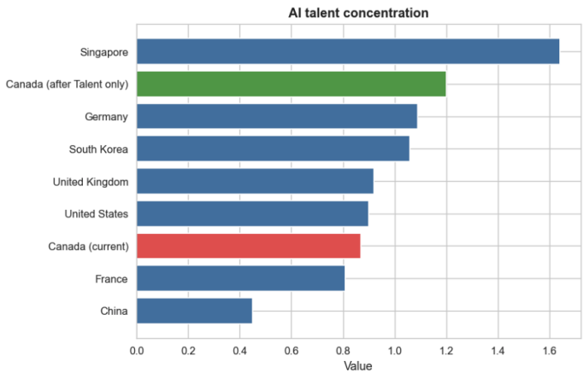 | 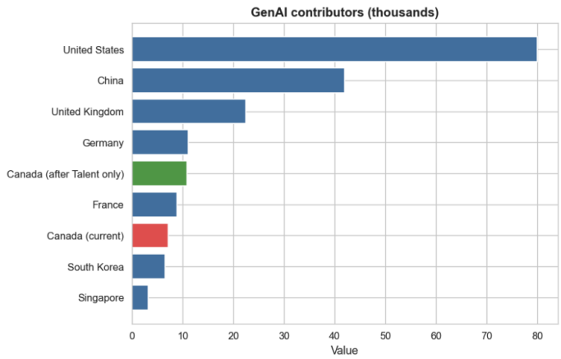

C.2 AI Compute Access Fund and Sovereign AI Computing: Canada vs. Benchmarked Peers
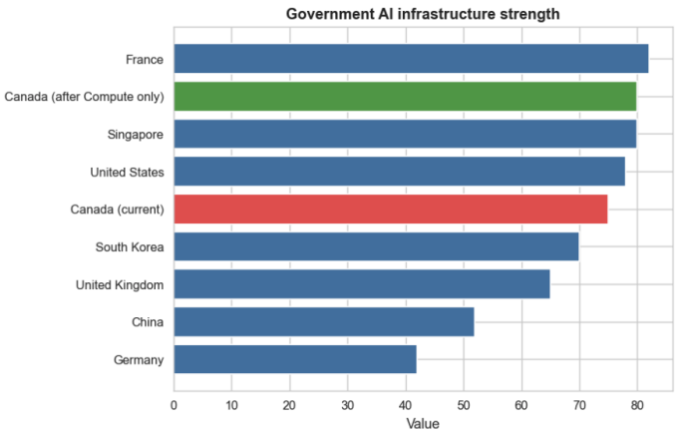 | 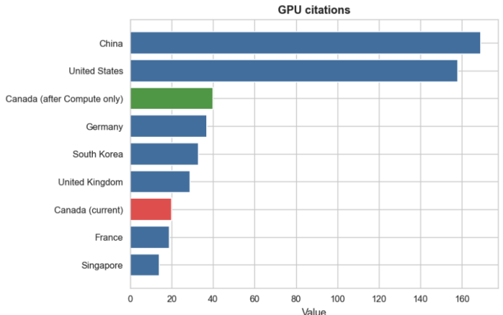

C.3 AI Governance Sprint and Regulation Office: Canada vs. Benchmarked Peers
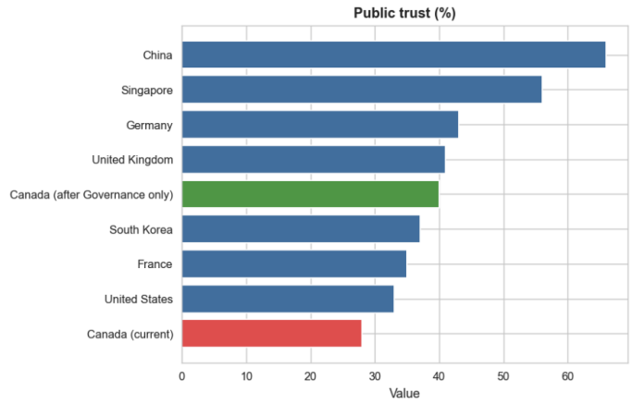 | 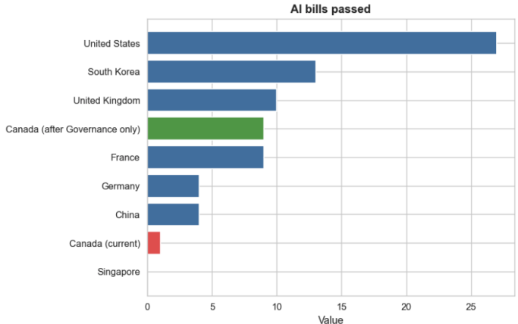

C.4 AI Venture Accelerator: Canada vs. Benchmarked Peers
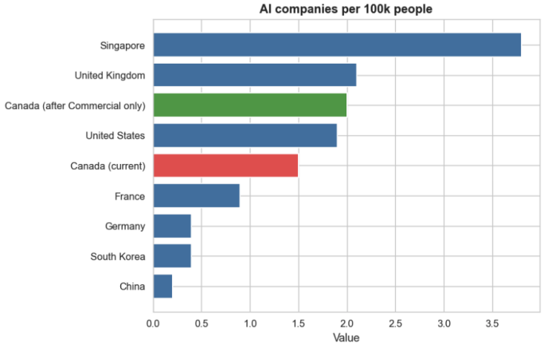 | 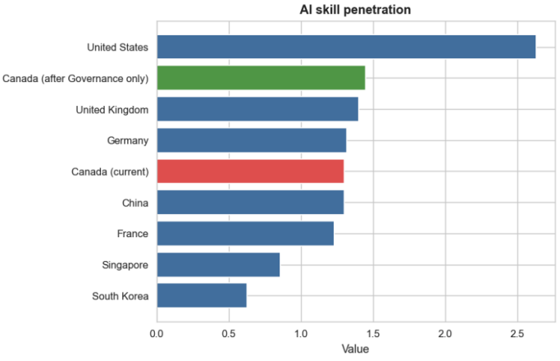

C.5 Cumulative Re-rank Projection: Canada vs. Benchmarked Peers
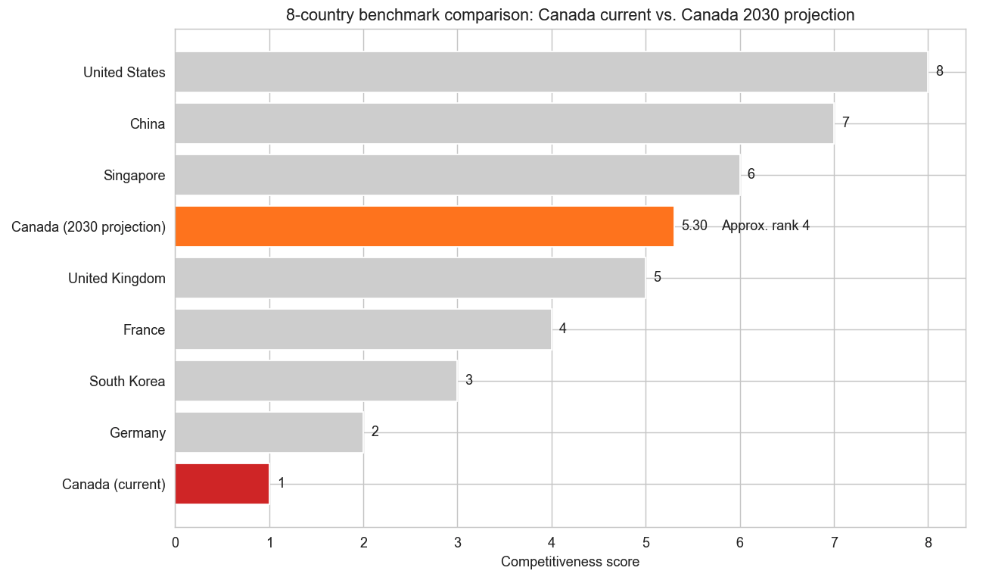

Appendix D: Supplementary Figures and Infographics

D.1 Diagnostic and priority visuals
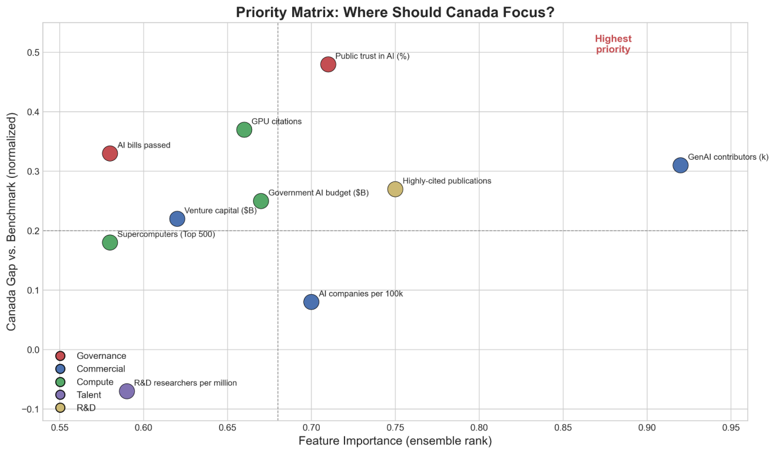
Figure D.1. Priority matrix (feature importance vs. Canada gap)

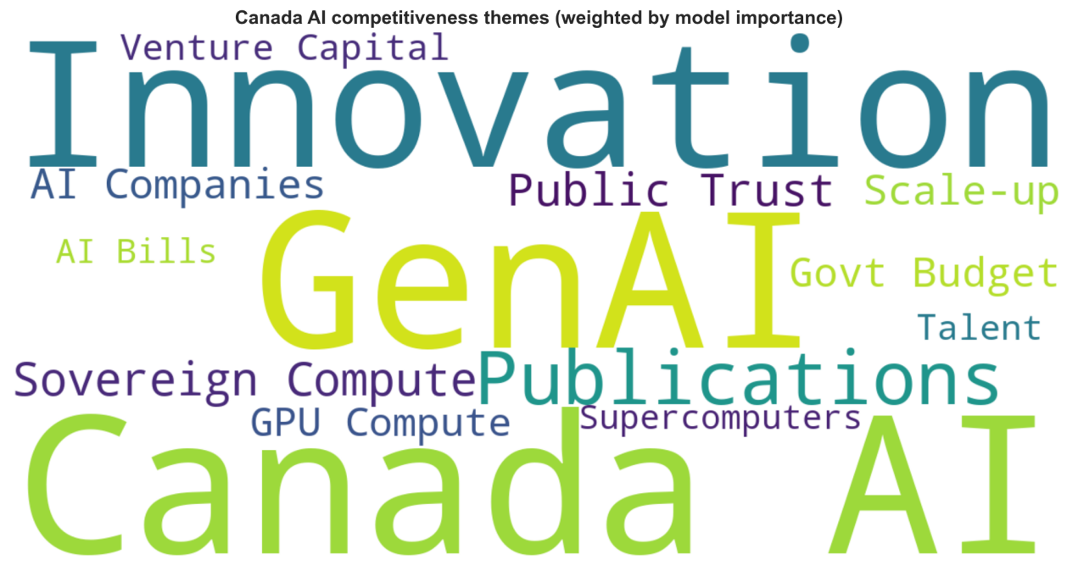
Figure D.2. Ecosystem keyword wordcloud

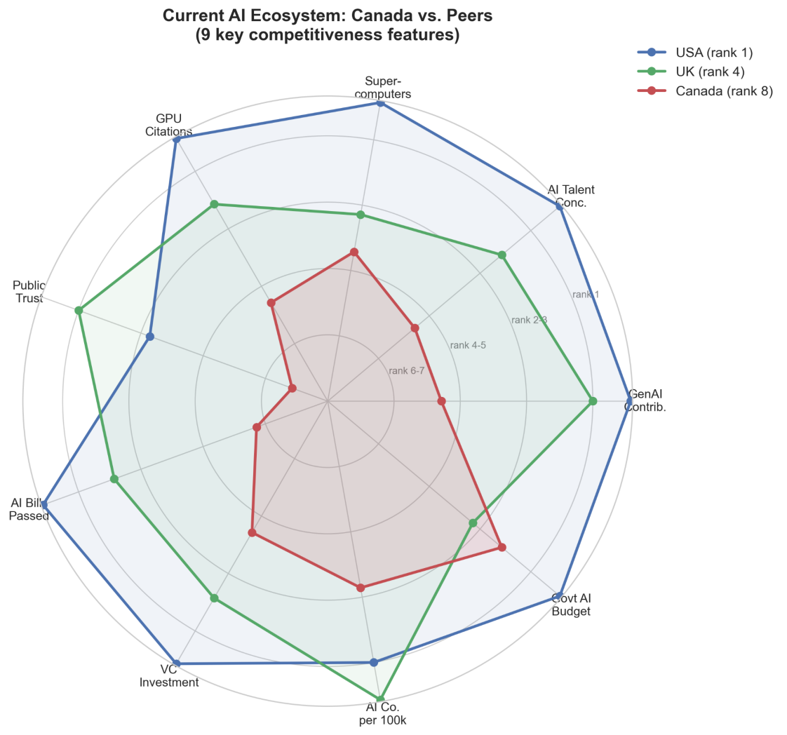
Figure D.3. Radar chart, Canada vs. peers

D.2 Policy impact and projection

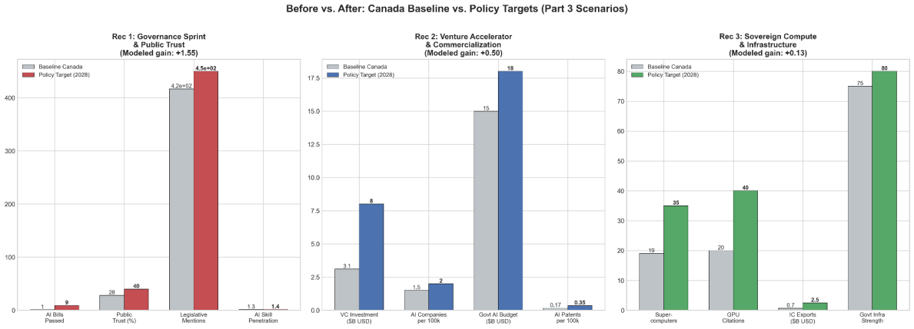
Figure D.4.Before/after recommendation targets

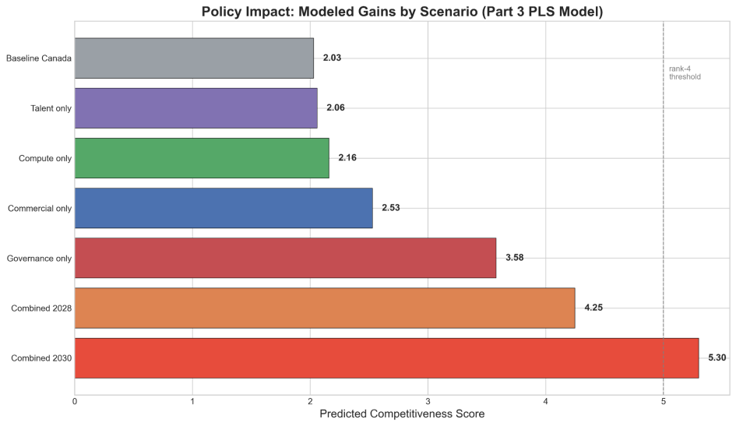
Figure D.5. Modelled impact by scenario

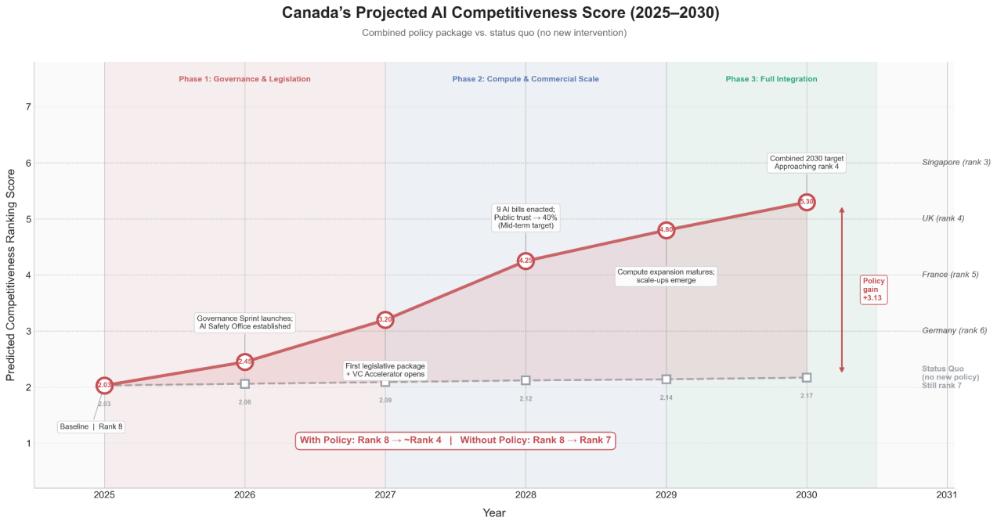
Figure D.6. Competitiveness score projection (policy vs. status quo)

D.3 Storytelling and PR framework
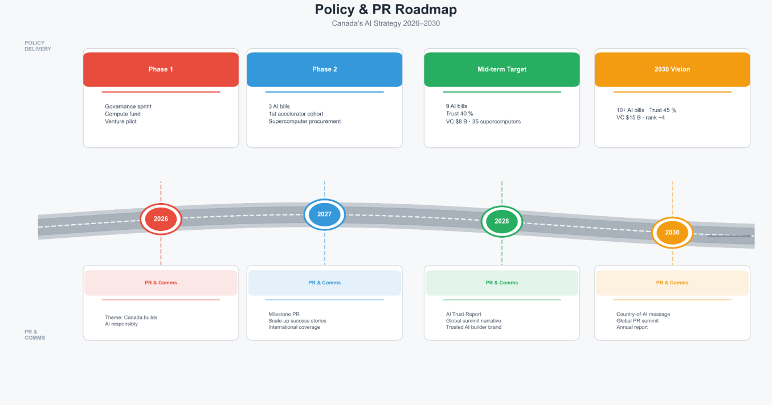
Figure D.7 — Implementation and PR roadmap

D.4 Social and campaign assets
Poster/infographic and X (Twitter) cards:

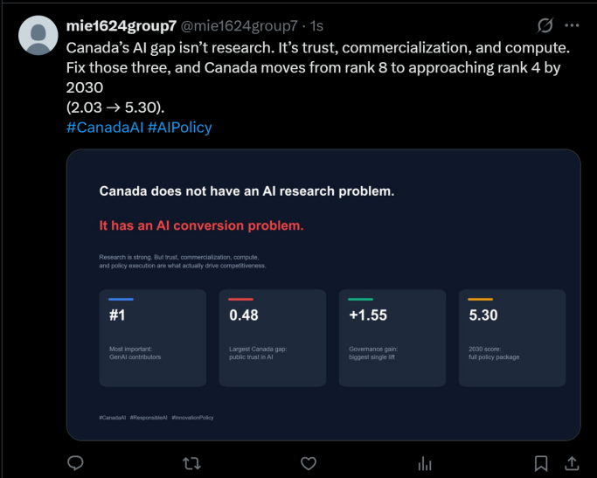 | 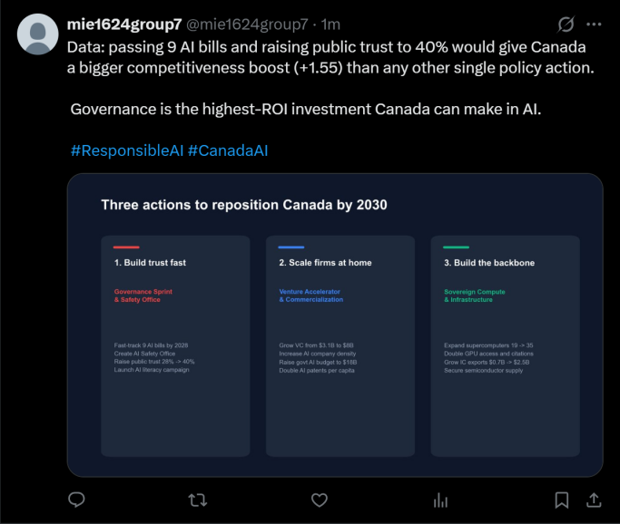
 | 